Truthful Auction-Based Resource Allocation in
Blockchain-Enabled Internet of Vehicles
A report submitted in partial fulfillment of the requirements for
the award of the degree of
Master of Science
Computer Science
By
Sagar Timalsena
(24419CMP025)

Department of Computer Science
Institute of Science
Banaras Hindu University, Varanasi – 221005

2025

ABSTRACT
The rapid growth of IoV significantly increases the demand for real-time computation, in-transit data processing, and secure communication among connected vehicles. Because of limited computational capacity, offloading tasks to proximate ECSPs becomes quite indispensable. However, the allocation of scarce ECSP resources to multiple competing vehicles in a fair, efficient, and truthful manner remains a major challenge. This project focuses on implementing and evaluating two auction-based resource allocation mechanisms namely, Constant Demand Auction Mechanism and Multi-Demand Auction Mechanism proposed for blockchain-enabled IoV environments.
The CDAM mechanism realizes an efficient allocation of the resources to vehicles of uniform demand and ensures truthfulness through bid-based selections, while MDAM handles heterogeneous vehicle demands using bid density and in-degree-based prioritization of ECSPs. Realistic datasets were generated for miners, ECSPs, and connectivity patterns, and both mechanisms were implemented with complete support for multi-ECSP using Python. Experiments were conducted by changing the number of ECSPs, and performances were analyzed from four aspects: social welfare, satisfaction, resource utilization, and execution time.
Results have shown that both CDAM and MDAM outperform the traditional allocation heuristics with high social welfare and efficient use of edge resources. While CDAM is faster, MDAM achieves better overall welfare owing to finer resource distribution across ECSPs. The experiment has shown that truthful auction mechanisms are highly suitable for secure and efficient resource allocation in IoV-based blockchain systems.
Keywords: Auction-based Resource Allocation, Blockchain, Constant and Multi-Demand Auction Mechanisms, Edge Computing, Internet of Vehicles (IoV), Social Welfare

CANDIDATE’S DECLARATION
I hereby certify that the work, which is being presented in the project report, Truthful Auction-Based Resource Allocation in Blockchain-Enabled Internet of Vehicles, in partial fulfilment of the requirement for the award of the Degree of Master of Computer Science and submitted to the institution is an authentic record of my own work carried out during the period Aug 2025 - Dec 2025 under the supervision of Dr. Anshul Verma.

I also cited the reference about the text(s)/figure(s)/table(s)/equation(s) from where they have been taken.
The matter presented in this report has not been submitted elsewhere for the award of any other degree or diploma from any institutions.

Date: ______________________ Signature of the Candidate

This is to certify that the above statement made by the candidate is correct to the best of my knowledge. The Viva-Voce examination of Sagar Timalsena, M.Sc. Student has been held on ……………………………..

_______________________ _____________________
Signature of Signature of
Research Supervisor(s) Head of the Department

ACKNOWLEDGEMENTS
I would like to express my heartfelt gratitude to everyone who supported me throughout the completion of this project. I am deeply thankful to my project supervisor, Dr. Anshul Verma, for their constant guidance, encouragement, and insightful feedback. Their expertise has played a crucial role in shaping the direction and quality of this work.
I am equally grateful to the professors and mentors of the Department of Computer Science, Banaras Hindu University, whose teachings and support have provided me with a strong academic foundation and the skills necessary for this project.
My sincere thanks also go to my family and friends for their unwavering encouragement, patience, and motivation throughout this journey. Their support has been a continuous source of strength.
Lastly, I extend my appreciation to all the participants and contributors whose involvement and cooperation have been vital to the successful completion of this project.

TABLE OF CONTENTS
ABSTRACT i
CANDIDATE’S DECLARATION ii
ACKNOWLEDGEMENTS iii
TABLE OF CONTENTS iv
LIST OF FIGURES v
LIST OF ABBREVIATIONS vi
CHAPTER 1: INTRODUCTION 1
1.1 Problem Statement 1
1.2 Objectives 2
CHAPTER 2: LITERATURE REVIEW 3
CHAPTER 3: METHODOLOGY 5
3.1 System Model 5
3.2 Auction-Based Resource Allocation Framework 5
3.3 Weighted Resource and Bid Density Model 5
3.4 Allocation Mechanism 6
3.5 Pricing and Payment Rule 6
CHAPTER 4: EXPERIMENT SETTINGS 7
4.1 Implementation Environment 7
4.2 Dataset Preparation 7
4.2.1 Miner Dataset 7
4.2.2 ECSP Dataset 8
4.2.3 Connectivity Matrix 9
4.3 Data Loading and Preprocessing 9
CHAPTER 5: RESULTS AND DISCUSSION 11
5.1 Satisfaction Ratio Analysis 11
5.2 ECSP Resource Utilization 12
5.3 Social Welfare Comparison 13
5.4 Profit Distribution Analysis 14
CHAPTER 6: CONCLUSION AND FUTURE WORK 15
6.1 Conclusion 15
6.2 Future Work 15
REFERENCE 16

LIST OF FIGURES
Figure 1 Miner Dataset 8
Figure 2 ESCP Dataset 9
Figure 3 Connectivity Matrix 9
Figure 4 Satisfaction Ratio Analysis 11
Figure 5 ECSP Resource Utilization 12
Figure 6 Social Welfare Comparison 13
Figure 7 Profit Distribution Analysis 14

LIST OF ABBREVIATIONS
CDAM Constant Demand Auction Mechanism
ECSP Edge Computing Service Provider
IoV Internet of Vehicles
MDAM Multi-Demand Auction Mechanism
PoW Proof of Work
SW Social Welfare
VCG Vickrey–Clarke–Groves Mechanism
Δ (Delta) Connectivity Matrix

CHAPTER 1: INTRODUCTION
It’s continuously under goes development and improvement, while the number of smart vehicles is growing rapidly; thus, IoV has appeared. IoV will connect vehicles, roadside infrastructure, cloud servers, and edge computing systems for real-time data sharing and intelligent decisions. A modern car is equipped with sensors, cameras, radars, and on-board systems able to generate a vast volume of data. The computational power needed for data processing in tasks such as:
- Collision avoidance
- Lane detection and autonomous driving
- Traffic Prediction
- Video and sensor data analytics
- Blockchain transaction validation
However, vehicles generally possess limited computational resources and are hence incapable of processing high-intensity tasks in real time. To overcome this limitation, Edge Computing Service Providers offer nearby computing and storage resources to which vehicles can offload tasks in order to achieve low latency and high performance.
At the same time, blockchain technology is increasingly adopted in IoV environments to provide secure, transparent, and tamper-proof communication. Vehicles act like miners in participating in the blockchain by validating transactions. This procedure requires computational resources, further increasing the demand for efficient resource allocation.

Problem Statement
In a mobile blockchain environment, multiple miners compete for limited computing resources offered by edge and cloud service providers. Traditional centralized resource allocation methods lack transparency, fairness, and incentive compatibility, and they do not account for the competitive and decentralized nature of blockchain networks. Moreover, inefficient allocation of computing resources can lead to increased latency, unfair access, reduced blockchain security, and poor utilization of available infrastructure.
Therefore, there is a need for an efficient and decentralized mechanism that can:
- Allocate limited cloud and edge computing resources fairly among competing miners,
- Encourage truthful participation of miners and service providers,
- Maximize overall social welfare while supporting blockchain security and performance.

Objectives
The primary objectives of this project are as follows:
- To study the hierarchical mobile blockchain architecture involving miners, edge computing service providers, and cloud service providers.
- To implement a hierarchical combinatorial auction mechanism for allocating computing resources in mobile blockchain networks.
- To model miner hash power, mining probability, and reward mechanisms based on allocated resources.
- To analyze social welfare maximization under limited computing resources.

CHAPTER 2: LITERATURE REVIEW
Blockchain has emerged as a foundational technology for decentralized data management by enabling transparency, immutability, and trust without dependence on centralized authorities. In public blockchain systems, consensus mechanisms such as Proof-of-Work (PoW) allow distributed participants, known as miners, to validate transactions and append new blocks to a shared ledger. Despite its strong security guarantees, PoW is computationally expensive and energy-intensive, which makes it impractical for resource-constrained devices such as smartphones, Internet of Things (IoT) nodes, and vehicles. To address these limitations[1], alternative consensus mechanisms, including Proof-of-Stake (PoS), Delegated Proof-of-Stake (DPoS), Practical Byzantine Fault Tolerance (PBFT), and Proof-of-Authority (PoA), have been proposed to reduce energy consumption, computation overhead, and confirmation latency. However, even with lightweight consensus protocols, many blockchain applications still require substantial computing resources, motivating the integration of blockchain with cloud, fog, and edge computing infrastructures where computation can be flexibly provisioned.[2]
A significant body of research identifies resource allocation as a core challenge in blockchain-enabled cloud and edge environments. Traditional centralized resource allocation approaches rely on trusted brokers or coordinators, which suffer from drawbacks such as single-point failure, lack of transparency, vulnerability to manipulation, and potential bias. Blockchain-based decentralized resource allocation models have therefore gained attention, as they leverage smart contracts and distributed ledgers to ensure immutable allocation records, transparent pricing, trustless coordination, and verifiable execution. These properties make blockchain a promising platform for managing computing resources across distributed cloud and edge systems.
The convergence of blockchain with edge computing has attracted particular interest due to the growing demand for low-latency, location-aware, and real-time services. Edge computing shifts computation closer to end devices, thereby reducing communication delay, bandwidth usage, and dependence on distant cloud data centers. Studies show that offloading blockchain-related tasks, such as mining or transaction validation, to edge servers can significantly improve consensus efficiency and enable broader participation from mobile and IoT devices. Nevertheless, edge resources are inherently limited compared to centralized cloud infrastructures, which necessitates efficient and fair allocation mechanisms to avoid congestion, underutilization, and unfair access. Auction-based resource allocation schemes have therefore been widely adopted to dynamically balance supply and demand in edge-assisted blockchain systems.[3]
In the context of the Internet of Vehicles (IoV), blockchain is increasingly employed to guarantee the authenticity, integrity, and non-repudiation of vehicular data. Vehicles can act as blockchain participants that generate and verify data, but their limited onboard computation and energy resources make direct execution of PoW-based mining infeasible[4]. To overcome this challenge, Edge Computing Service Providers (ECSPs) are deployed to support vehicular miners by offering nearby computational resources[5]. Auction-based mechanisms, such as constant-demand and multi-demand auctions, have been shown to efficiently allocate edge resources to vehicles, improving resource utilization, miner satisfaction, and overall system performance while maintaining incentive compatibility and fairness.
Beyond single-layer architectures, researchers have also investigated hierarchical resource allocation models that integrate edge and cloud computing. In these architectures, miners first request resources from local edge servers, which may further offload excess demand to remote cloud data centers when local capacity is insufficient. Hierarchical and combinatorial auction frameworks have been proposed in which mobile edge service providers act as intermediaries between miners and cloud providers. Experimental results indicate that such hierarchical designs can achieve high resource utilization, preserve truthfulness, and improve scalability in large-scale mobile blockchain environments.[6]
Another critical aspect explored in the literature is the role of network effects in blockchain systems. The security, robustness, and economic value of a blockchain particularly those based on PoW or stake-based mechanisms grow with the total amount of computing power or stake contributed by participants. As a result, miners’ valuations depend not only on individual rewards but also on the aggregate level of participation in the network. To capture this interdependence, several studies incorporate network effect functions into social welfare formulations. [7]These functions are typically modeled as concave and monotonically increasing, reflecting diminishing marginal returns as the network expands. Incorporating network effects into resource allocation and pricing models has been shown to significantly influence optimal allocation strategies and improve overall system efficiency in blockchain-enabled cloud and edge computing environments.

CHAPTER 3: METHODOLOGY
This chapter describes the methodology adopted to design, implement, and evaluate truthful auction mechanisms for resource allocation in a blockchain-enabled Internet of Vehicles (IoV) environment. The methodology follows the same research approach as the original paper and combines system modeling, auction-theoretic mechanism design, mathematical validation, and simulation-based experimentation. The objective is to ensure efficient, fair, and truthful allocation of limited edge computing resources among competing vehicles.

3.1 System Model
The system model consists of three main entities: vehicles (miners), Edge Computing Service Providers (ECSPs), and a public blockchain network. Vehicles generate blockchain-related computational tasks and submit requests to offload these tasks to nearby ECSPs due to limited onboard computational capacity. ECSPs provide CPU and storage resources with finite capacity and associated operational costs.
A public blockchain is used to record bidding, allocation, and payment information in a transparent and tamper-proof manner. Since multiple vehicles compete for limited ECSP resources, an auction-based resource allocation framework is adopted to resolve contention in a decentralized and trustworthy way.

Auction-Based Resource Allocation Framework
The methodology is grounded in auction theory, where vehicles act as buyers bidding for edge resources, and ECSPs act as sellers offering computational capacity. Two auction mechanisms are considered based on the nature of vehicle demand:
- Constant Demand Auction Mechanism (CDAM): Used when all vehicles request uniform amounts of resources.
- Multi-Demand Auction Mechanism (MDAM): Used when vehicles have heterogeneous CPU and storage demands.
In this work, the focus is primarily on the MDAM mechanism, as it more accurately reflects real-world IoV scenarios.

Weighted Resource and Bid Density Model
To handle multidimensional resource requests, the methodology introduces a weighted resource model. Each vehicle’s demand is converted into a single scalar value using a weighting factor:
$$d_{i}=α.{CPU}_{i}+(1-α).{Storage}_{i}$$
where 𝛼 is the weight factor that balances the importance of CPU and storage resources.
Each vehicle submits a bid representing its valuation for the requested resources. The bid density, defined as the ratio of bid value to weighted resource demand, is used as the primary allocation metric:
$${Bid Density}_{i}=\frac{b_{i}}{d_{i}}$$
This approach allows fair comparison among vehicles with different demand sizes.

Allocation Mechanism
The allocation process follows a greedy bid-density-based strategy, as defined in the MDAM mechanism. Vehicles are sorted in descending order of bid density. Resources are allocated sequentially to vehicles as long as the ECSP has sufficient remaining capacity and the bid density satisfies the minimum ask density condition of the ECSP.
For CDAM, the allocation problem is modeled as a maximum-cost maximum-flow optimization problem, ensuring optimal social welfare when demands are uniform. For MDAM, a heuristic approach is used to ensure computational efficiency in large-scale IoV environments.

Pricing and Payment Rule
To ensure truthfulness and fairness, a clearing-price-based payment rule is adopted. The payment for each winning vehicle is calculated using the average of the vehicle’s bid density and the ECSP’s ask density, multiplied by the weighted resource demand:
$$p_{i}=\frac{({Bid Density }_{i}+ Ask Density)}{2}.d_{i}$$

CHAPTER 4: EXPERIMENT SETTINGS
This chapter describes the practical implementation of the proposed auction mechanisms Constant Demand Auction Mechanism (CDAM) and Multi-Demand Auction Mechanism (MDAM) used for resource allocation in an Internet of Vehicles (IoV) environment. The implementation was carried out using Python to simulate miner behavior, ECSP resource availability, and the auction-based allocation process.[5]

4.1 Implementation Environment
The system was implemented using the following tools and technologies:
- Programming Language: Python 3
- Libraries:
  - Pandas for data manipulation and storage
  - NumPy for numerical and matrix operations
  - Matplotlib for plotting experimental results
Python was selected due to its readability, flexibility, and strong support for data analysis and simulation.

4.2 Dataset Preparation
To simulate a realistic IoV scenario, three different datasets were created.

4.2.1 Miner Dataset
Each vehicle in the IoV network is treated as a miner. The miner dataset includes the following attributes:
- Miner ID
- CPU demand
- Storage demand
- Weighted resource demand
- Bid value
- Bid density
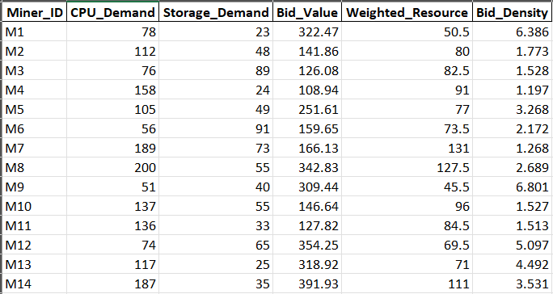

Figure 1 Miner Dataset
These values were generated randomly within predefined ranges to represent varying vehicle requirements and willingness to pay. The miner dataset was stored in the file miners.csv.

4.2.2 ECSP Dataset
Edge Computing Service Providers (ECSPs) offer limited computing and storage resources to miners. The ECSP dataset includes:
- ECSP ID
- CPU capacity
- Storage capacity
- Cost values (CPU and Storage)
- Weighted capacity
- Ask Density
This dataset models the resource availability at the edge and was stored in ecsp.csv.
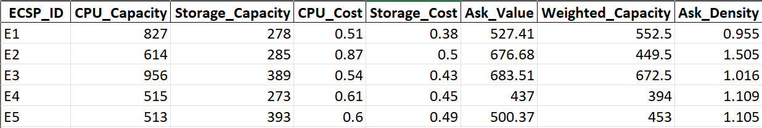
Figure 2 ESCP Dataset

4.2.3 Connectivity Matrix
In real IoV systems, a vehicle cannot connect to all ECSPs due to network coverage and distance constraints. To represent this limitation, a connectivity matrix (Δ) was generated.
Δᵢⱼ = 1 indicates that miner i can connect to ECSP j
Δᵢⱼ = 0 indicates no possible connection.
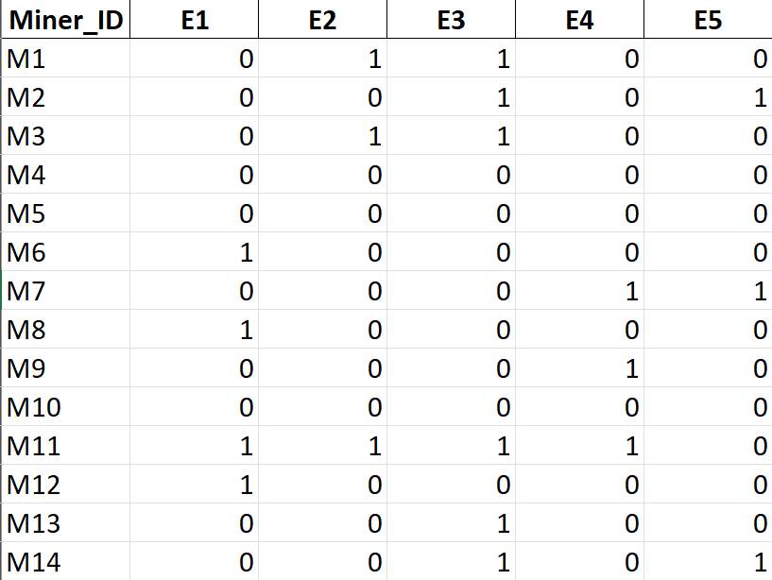
Figure 3 Connectivity Matrix
The connectivity information was stored in connectivity_matrix.csv and was used to restrict invalid allocations.

4.3 Data Loading and Preprocessing
All datasets were loaded from CSV files using the pandas library. Preprocessing steps such as matrix conversion and parameter extraction were performed to prepare the data for allocation algorithms. This modular approach allows the experiment to be repeated with different datasets without modifying the core code.

CHAPTER 5: RESULTS AND DISCUSSION
This chapter presents the experimental results obtained from the implementation and evaluation of the CDAM and MDAM auction mechanisms for resource allocation in a blockchain-enabled Internet of Vehicles (IoV) environment. The results are generated using identical miner and ECSP datasets to ensure a fair comparison. Performance is evaluated using key metrics such as satisfaction ratio, resource utilization, profit distribution, and social welfare. Graphical illustrations are used to support the analysis.

5.1 Satisfaction Ratio Analysis
The satisfaction ratio represents the percentage of miners that successfully receive computing resources from the Edge Computing Service Provider (ECSP).
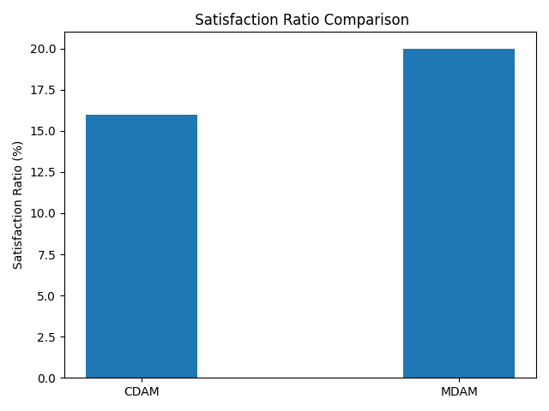
Figure 4 Satisfaction Ratio Analysis

Figure 4 shows the satisfaction ratio comparison between CDAM and MDAM. It is observed that the satisfaction ratios differ between the two mechanisms due to their distinct allocation strategies. CDAM tends to allocate resources to a larger number of miners, resulting in a relatively higher satisfaction ratio. In contrast, MDAM performs more selective allocation by prioritizing miners with higher bid density, which may reduce satisfaction but improves allocation efficiency.
This result highlights the trade-off between fairness (serving more miners) and efficiency (serving high-value miners).

5.2 ECSP Resource Utilization
Efficient utilization of edge computing resources is crucial in IoV environments due to limited computational capacity.
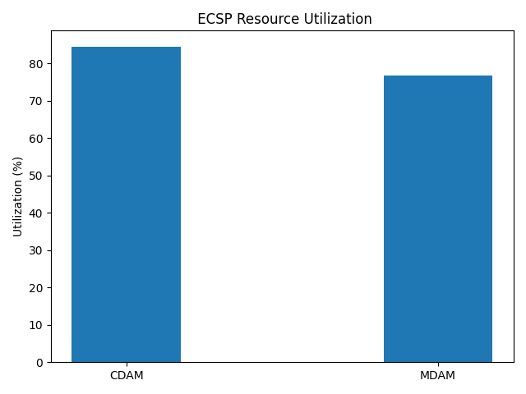
Figure 5 ECSP Resource Utilization
Figure 5 illustrates the ECSP resource utilization achieved by CDAM and MDAM. The results show that MDAM achieves higher utilization compared to CDAM. This is because MDAM allocates resources to miners with higher valuation per unit resource, thereby minimizing resource wastage. CDAM, while serving more miners, may leave fragmented or underutilized resources.

These results demonstrate that MDAM is more effective in maximizing ECSP resource utilization.

5.3 Social Welfare Comparison
Social welfare is defined as the sum of total miner profit and ECSP profit. It represents the overall benefit achieved by the system.
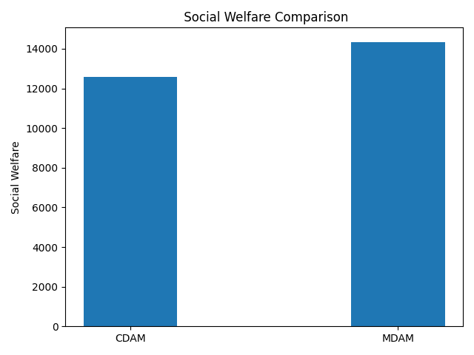
Figure 6 Social Welfare Comparison
Figure 6 presents the social welfare comparison between CDAM and MDAM. The results indicate that MDAM consistently achieves higher social welfare than CDAM. This improvement is mainly due to better resource utilization and higher ECSP profit under MDAM. By allocating resources to miners with higher bid density, MDAM ensures that system-wide benefits are maximized.
This confirms that MDAM is more suitable for scenarios where overall system efficiency is the primary objective.

5.4 Profit Distribution Analysis
To analyze economic fairness and incentive compatibility, profit distribution for miners and the ECSP is examined.
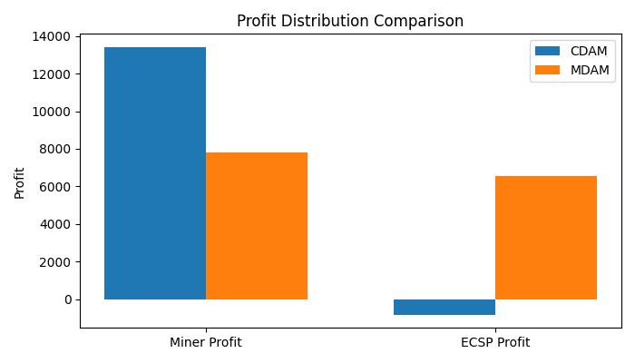
Figure 7 Profit Distribution Analysis
Figure 7 compares miner profit and ECSP profit under both CDAM and MDAM mechanisms. The results show that:
- Both mechanisms ensure non-negative miner profit, satisfying individual rationality.
- MDAM provides higher ECSP profit due to higher clearing prices and efficient allocation.
- CDAM distributes profit more evenly among miners but yields lower ECSP profit.
These observations confirm that both mechanisms are economically viable, but MDAM offers stronger incentives for ECSP participation.

CHAPTER 6: CONCLUSION AND FUTURE WORK

6.1 Conclusion
This project studied and implemented a truthful auction–based resource allocation framework for the Internet of Vehicles (IoV) integrated with public blockchain networks. The primary objective was to address the computational limitations of vehicular devices participating in Proof-of-Work–based blockchain systems by leveraging edge computing services. By introducing an auction mechanism, the proposed approach enables efficient, fair, and transparent allocation of limited edge computing resources among competing vehicles.
The implementation demonstrated how vehicles can offload blockchain mining tasks to Edge Computing Service Providers (ECSPs) while maintaining blockchain security, data integrity, and decentralization. The use of truthful auction mechanisms ensures incentive compatibility, encouraging vehicles to submit honest bids without benefiting from strategic manipulation. The resource allocation model also incorporates deployment constraints and network effects, providing a realistic representation of vehicular mobility and blockchain security dynamics.
Overall, the proposed framework improves resource utilization, reduces mining latency, and enhances the robustness of blockchain-based IoV systems. The integration of blockchain, edge computing, and auction theory offers a practical and scalable solution for secure vehicular data management in future intelligent transportation systems.

6.2 Future Work
Though the proposed framework effectively addresses resource allocation challenges in blockchain-enabled Internet of Vehicles (IoV) environments, several directions can be explored to further enhance its performance and applicability. One important extension is the integration of alternative consensus mechanisms. Future work may investigate lightweight consensus protocols such as Proof-of-Stake or Practical Byzantine Fault Tolerance to significantly reduce energy consumption and computational overhead, making the framework more suitable for resource-constrained vehicular and edge environments. Another promising direction is the incorporation of dynamic mobility-aware resource allocation. Additionally, extending the framework to support multi-ECSP and cooperative edge computing models represents a valuable enhancement. Enabling cooperation among multiple ECSPs can improve scalability, load balancing, and fault tolerance, thereby ensuring more reliable and efficient service delivery in large-scale vehicular networks.

REFERENCE
[1] J. Zhang, W. Lou, H. Sun, Q. Su, and W. Li, “Truthful auction mechanisms for resource allocation in the Internet of Vehicles with public blockchain networks,” Futur. Gener. Comput. Syst., vol. 132, pp. 11–24, 2022, doi: https://doi.org/10.1016/j.future.2022.02.002.
[2] Y. Jiao, P. Wang, S. Member, and D. Niyato, “Auction Mechanisms in Cloud / Fog Computing Resource Allocation for Public Blockchain Networks,” vol. 30, no. 9, pp. 1975–1989, 2019.
[3] L. Li, Y. Li, and R. Li, “Double Auction-Based Two-Level Resource Allocation Mechanism for Computation Offloading in Mobile Blockchain Application,” vol. 2021, 2021, doi: 10.1155/2021/8821583.
[4] G. Baranwal, D. Kumar, and D. Prakash, “Blockchain based resource allocation in cloud and distributed edge computing : A survey,” Comput. Commun., vol. 209, no. April, pp. 469–499, 2023, doi: 10.1016/j.comcom.2023.07.023.
[5] Z. Shi, C. De Laat, and P. Grosso, “Integration of Blockchain and Auction Models : A Survey , Some Applications , and Challenges,” IEEE Commun. Surv. Tutorials, vol. 25, no. 1, pp. 497–537, 2023, doi: 10.1109/COMST.2022.3222403.
[6] S. Li, K. Zhu, Y. Xu, R. Wang, and Y. Zhao, “Resource Allocation for Mobile Blockchain : A Hierarchical Combinatorial Auction Approach,” 2019.
[7] J. Zhang, W. Lou, H. Sun, Q. Su, and W. Li, “Truthful auction mechanisms for resource allocation in the Internet of Vehicles with public blockchain networks,” Futur. Gener. Comput. Syst., vol. 132, pp. 11–24, 2022, doi: 10.1016/j.future.2022.02.002.

